Document Date: July 20, 2026

Snap-Lock Modular Shielding Covers for MCT and Geophone ADC Zones
Local Faraday Cages for 100 MHz–3 GHz Near-Field Coupling Attenuation
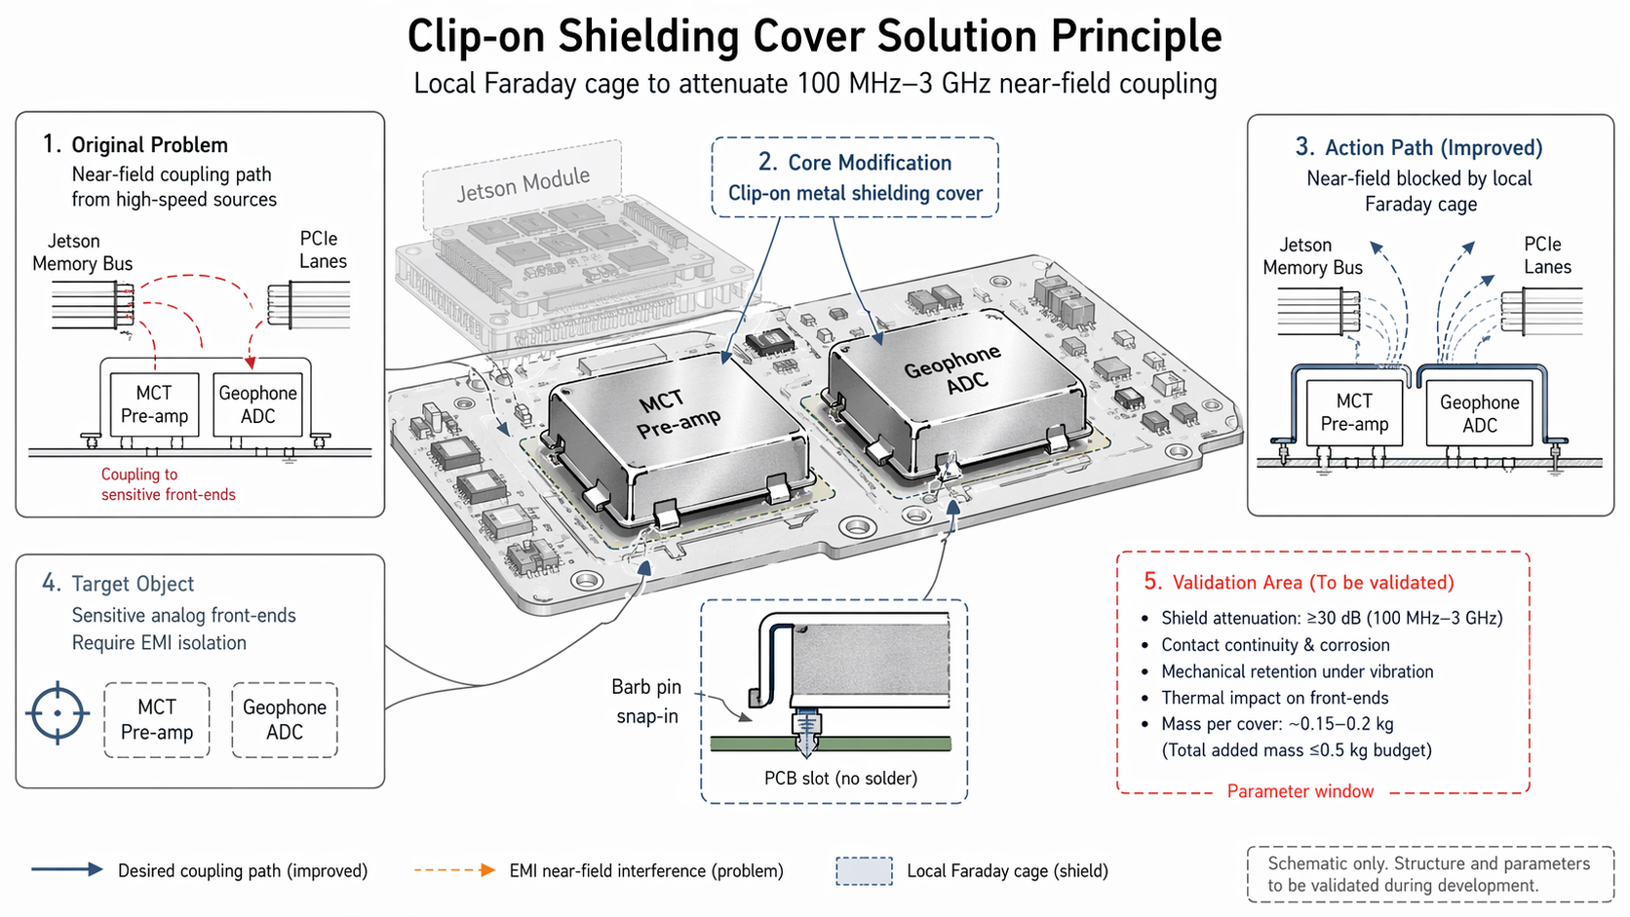

Executive Summary
This document describes the installation of clip-on metal shielding covers with convex hull geometry and barb pin snap-in retention directly over the MCT detector pre-amplifier and geophone ADC front-end zones on the PCB. These covers form local Faraday cages that attenuate 100 MHz–3 GHz near-field electromagnetic coupling from adjacent high-speed digital buses (Jetson memory bus, PCIe lanes). The snap-lock design enables tool-free field removal for sensor maintenance while maintaining ≥30 dB isolation during operation. At ~0.15–0.2 kg per cover and ≤0.5 kg total EMI mitigation mass budget, the solution preserves a simple PCB layout for field repairability.

1. Problem Statement
Sensitive analog front-end circuits on the PCB are subject to near-field electromagnetic interference (EMI) coupling from adjacent high-speed digital sources. The primary coupling paths are:
- Jetson Memory Bus Coupling
- High-speed memory interface signals (100 MHz–1 GHz fundamental + harmonics) capacitively and inductively couple into the MCT pre-amplifier input traces, introducing noise that degrades detector signal-to-noise ratio.
- PCIe Lane Coupling
- Multi-gigabit PCIe data lanes (up to 3 GHz effective frequency) radiate near-field energy that couples into the geophone ADC analog input section, causing quantization noise and spurious frequency components.
The sensitive front-ends (MCT Pre-amp and Geophone ADC) require EMI isolation to maintain measurement fidelity, but traditional shielding solutions (soldered cans, conformal coating) compromise field serviceability and PCB layout flexibility.

2. Solution Principle
Install clip-on metal shielding covers directly over the sensitive front-end zones. Each cover forms a local Faraday cage that blocks near-field coupling while remaining removable for maintenance.
Parameter | Specification | Purpose
Shielding Cover Geometry | Convex hull over component zone | Maximizes internal volume; minimizes edge diffraction
Retention Mechanism | Barb pin snap-in to PCB slot | Tool-free installation/removal; no solder required
PCB Interface | PCB slot (no solder) | Preserves PCB layout; enables field replacement
Shielding Effectiveness | ≥30 dB @ 100 MHz–3 GHz | Attenuates near-field coupling from adjacent buses
Mass per Cover | ~0.15–0.2 kg | Stays within ≤0.5 kg total EMI mitigation budget

3. System Architecture

3.1 Shielded Zones
Zone | Component | Threat Source | Coupling Mechanism
Zone 1 | MCT Pre-amplifier | Jetson Memory Bus | Capacitive + inductive near-field coupling (100 MHz–1 GHz)
Zone 2 | Geophone ADC | PCIe Lanes | Near-field radiation coupling (up to 3 GHz)

3.2 Action Path (Improved)
Before (Problem):
- Jetson Memory Bus → near-field radiation → couples into MCT Pre-amp input traces (dashed red path).
- PCIe Lanes → near-field radiation → couples into Geophone ADC analog section (dashed red path).
After (Improved):
- Jetson Memory Bus → near-field radiation → blocked by MCT Pre-amp shield cover (local Faraday cage) → attenuated coupling to MCT Pre-amp (solid blue path).
- PCIe Lanes → near-field radiation → blocked by Geophone ADC shield cover (local Faraday cage) → attenuated coupling to Geophone ADC (solid blue path).
The local Faraday cages confine the near-field energy to the digital source regions and prevent it from reaching the sensitive analog front-ends. The shield covers do not affect the desired signal paths (MCT detector output to pre-amp, geophone signal to ADC) which remain internal to each shielded zone.

4. Mechanical Design

4.1 Convex Hull Geometry
The shield cover is formed as a convex hull over the component zone, providing:
- Maximum internal clearance above components and traces, preventing shorting or capacitive loading.
- Smooth exterior surfaces that minimize edge diffraction and scattering of incident EM energy.
- Structural rigidity that resists deformation under vibration and thermal cycling.

4.2 Barb Pin Snap-In Retention
The cover features barb pins that snap into pre-machined slots in the PCB:
- Installation: Press cover down until barb pins engage PCB slots; audible/tactile snap confirms retention.
- Removal: Apply upward force to disengage barb pins; no tools, heat, or solder required.
- Grounding: Barb pins make electrical contact with PCB ground plane through the slot plating, ensuring shield-to-ground continuity.

4.3 PCB Slot Design
PCB slots are designed with:
- Plated through-holes or surface pads that connect to the PCB ground plane.
- Tolerance to accommodate barb pin dimensions and ensure reliable snap engagement.
- No solder requirement — the mechanical snap-fit provides both retention and electrical contact.

5. Performance Targets & Mass Budget
Parameter | Target | Rationale
Shield Attenuation | ≥30 dB @ 100 MHz–3 GHz | Sufficient to reduce near-field coupling below noise floor of sensitive front-ends
Mass per Cover | ~0.15–0.2 kg | Lightweight metal stamping or drawn sheet construction
Total Added Mass | ≤0.5 kg (EMI mitigation budget) | Accommodates 2–3 shield covers + other EMI components
Field Serviceability | Tool-free removal < 30 seconds | Enables rapid sensor maintenance without soldering equipment

6. TRIZ / Systematic Innovation Principles
The technical contradiction addressed: the shielding must be permanent and robust (for EMI effectiveness) and removable and accessible (for field maintenance).

6.1 Principle #1 — Segmentation
The monolithic PCB shielding approach (full-board soldered can or conformal coating) is segmented into discrete, localized shield covers:
- Each sensitive zone (MCT Pre-amp, Geophone ADC) receives its own dedicated shield cover.
- Shield covers are independent — removal of one does not affect the other.
- Segmentation allows targeted shielding only where needed, reducing mass and preserving access to non-sensitive areas.

6.2 Principle #2 — Extraction
The "extract" principle is applied by removing the shielding function from the PCB itself and extracting it into a separate, removable component:
- The PCB remains a simple, unshielded layout — easy to manufacture, test, and repair.
- The shielding function is extracted into the clip-on cover — a separate part that can be optimized, replaced, or upgraded independently.
- This separation of concerns simplifies both the PCB design and the shielding design, enabling parallel development and independent validation.

7. Bottleneck Solved
The snap-lock modular shielding covers resolve the following critical bottlenecks:
- Near-Field Coupling Eliminated
- The local Faraday cages block 100 MHz–3 GHz near-field radiation from the Jetson memory bus and PCIe lanes, preventing noise injection into the MCT pre-amp and geophone ADC.
- Tool-Free Field Serviceability
- Barb pin snap-in retention enables rapid cover removal and reinstallation without soldering irons, heat guns, or specialized tools. Sensor maintenance time is reduced from hours to minutes.
- PCB Layout Preserved
- The simple PCB slot interface requires no shielding-specific routing, ground vias, or solder mask modifications. The PCB layout remains clean and field-repairable.
- Mass Budget Maintained
- At ~0.15–0.2 kg per cover, the total EMI mitigation mass stays well within the ≤0.5 kg budget, preserving payload capacity for other mission-critical components.

8. Validation & Verification Plan
Validation Item | Test Condition / Target | Verification Method
Shield Attenuation | ≥30 dB @ 100 MHz–3 GHz | Near-field probe measurement with and without cover; compare coupling levels
Contact Continuity & Corrosion | Ground resistance < 10 mΩ per pin; no corrosion after mission life | Four-wire resistance measurement; salt fog + thermal cycling per ASTM B117
Mechanical Retention | No loosening or disengagement under vibration (50–400 Hz, 40°C) | Random vibration test per MIL-STD-810G; inspect retention after test
Thermal Impact | No temperature rise > 5°C in shielded components | Thermal imaging during full-power operation; compare with/without cover
Mass Verification | ~0.15–0.2 kg per cover; ≤0.5 kg total | Precision weighing; confirm against EMI mitigation budget

9. References
- [1] Patent/Citation — Welding-free circuit board shielding cover structure (barb pin snap-in retention reference)
- [2] Altshuller, G. — TRIZ: 40 Principles of Inventive Problem Solving (Principle #1: Segmentation; Principle #2: Extraction)
- [3] MIL-STD-810G — Environmental Engineering Considerations and Laboratory Tests (vibration testing)
- [4] ASTM B117 — Standard Practice for Operating Salt Spray (Fog) Apparatus for corrosion testing
— Document generated July 20, 2026 —

